

Dokumentimi I detyrave te shtepise.

Kapitulli 4

**Console Input and Output**

Prof:Muzafer Shala

Ass:Laberion Zebica Student: Adhurim Haziri

Kampusi:FERIZAJ

1. Write a program that **reads** from the console **three numbers** of type **int** and prints their sum.

using System;

namespace ConsoleApp16

{

class Program

{

static void Main(string[] args)

{

static void Main(string[] args)

{

Console.Write("Enter radius: ");

int a = Int32.Parse(Console.ReadLine());

Console.Write("Second number: ");

int b = Int32.Parse(Console.ReadLine());

Console.Write("Third number: ");

int c = Int32.Parse(Console.ReadLine());

Console.WriteLine("Result is {0}", a + b + c);

}

}

}

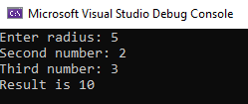}

1. Write a program that **reads** from the console the **radius** "**r**" of a circle and prints its **perimeter** **and area**.

using System;

namespace ConsoleApp16

{

class Program

{

static void Main(string[] args)

{

static void Main(string[] args)

{

Console.Write("Enter radius: ");

int r = Int32.Parse(Consle.ReadLine());

Console.WriteLine("P is {0} and S is {1}", 2 * Math.PI * r, Math.PI * r * r);

}

}

}

}

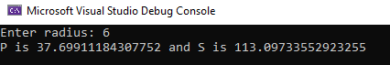

1. A given company has name, address, phone number, fax number, web site and manager. The manager has name, surname and phone number. Write a program that **reads information about the company** and its manager and then **prints it** on the console.

using System;

using System.Collections.Generic;

using System.Linq;

using System.Text;

using System.Threading.Tasks;

namespace Chapter_4_Solution_3

{

class Program

{

static void Main(string[] args)

{

Console.Write("Enter company name: ");

string compName = Console.ReadLine();

Console.Write("Enter company address: ");

string compAddr = Console.ReadLine();

Console.Write("Enter company phone number: ");

string compPhone = Console.ReadLine();

Console.Write("Enter company fax: ");

string compFax = Console.ReadLine();

Console.Write("Enter company website: ");

string compSite = Console.ReadLine();

Console.Write("Enter company manager: ");

string compManager = Console.ReadLine();

Console.Write("Enter manager first name: ");

string managerFName = Console.ReadLine();

Console.Write("Enter manager last name: ");

string managerLName = Console.ReadLine();

Console.Write("Enter manager phone: ");

string managerPhone = Console.ReadLine();

Console.WriteLine("Firm: Name - {0}, Address - {1}, Number - {2}, Fax - {3}, Website - {4}, Manager - {5}", compName, compAddr, compPhone, compFax, compSite, compManager);

Console.WriteLine("Manager: Name - {0} {1}, Phone - {2}",managerFName, managerLName, managerPhone);

}

}

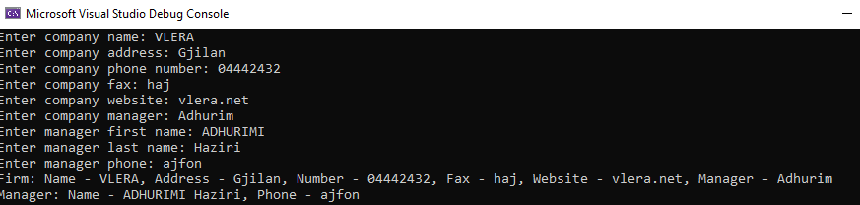}

1. Write a program that **prints three numbers in three virtual columns** on the console. Each column should have a width of 10 characters and the numbers should be **left aligned**. The first number should be an integer in **hexadecimal**; the second should be **fractional positive**; and the third – a **negative fraction**. The last two numbers have to be rounded to the second decimal place.

using System;

namespace ConsoleApp17

{

class Program

{

static void Main(string[] args)

{

static void Main(string[] args)

{

int hexNum = 2015;

Console.WriteLine("|0x{0,-8:X|", hexNum);

double fractNum = -1.856;

Console.WriteLine("|0,-10:f2}|", fractNum);

}

}

}

}

1. Write a program that reads from the console two integer numbers (**int**) and prints how many numbers between them exist, such that **the remainder of their division by 5 is 0**. Example: in the range (14, 25) there are 3 such numbers: 15, 20 and 25.

using System;

namespace ConsoleApp17

{

class Program

{

static void Main(string[] args)

{

static void Main(string[] args)

{

static void Main(string[] args)

{

int counter = 0;

Console.Write("Enter first number: ");

int a = Int32.Parse(Console.ReadLine());

Console.Write("Enter second number: ");

int b = Int32.Parse(Console.ReadLine());

for (int i = a; i <= b; i++)

{

if (i % 5 == 0) counter++;

}

Console.WriteLine("{0} numbers found.", counter);

}

}

}

}

}

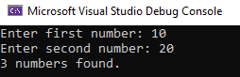

1. Write a program that reads two numbers from the console and **prints the greater of them**. Solve the problem without using conditional statements.

using System;

namespace ConsoleApp17

{

class Program

{

static void Main(string[] args)

{

static void Main(string[] args) {

static void Main(string[] args)

{

static void Main(string[] args)

{

Console.Write("Enter first number: ");

int a = Int32.Parse(Console.ReadLine());

Console.Write("Enter second number: ");

int b = Int32.Parse(Console.ReadLine());

Console.WriteLine("{0} >= {1}", Math.Max(a, b), Math.Min(a, b));

}

}

}

}

}

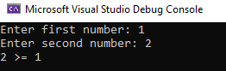}

1. Write a program that **reads five integer numbers and prints their sum**. If an invalid number is entered the program should prompt the user to enter another number.

using System;using System.Collections.Generic;

using System.Linq;

using System.Text;

using System.Threading.Tasks;

namespace Chapter_4_Solution_7

{

class Program

{

static void Main(string[] args)

{

int a, b, c, d, e;

bool parseSucceed = false;

do

{

Console.Write("Enter first number");

parseSucceed = Int32.TryParse(Console.ReadLine(), out a);

Console.WriteLine(parseSucceed);

} while (!parseSucceed);

do

{

Console.Write("Enter second number");

parseSucceed = Int32.TryParse(Console.ReadLine(), out b); Console.WriteLine(parseSucceed);

} while (!parseSucceed);

do

{

Console.Write("Enter third number");

parseSucceed = Int32.TryParse(Console.ReadLine(), out c);

Console.WriteLine(parseSucceed);

} while (!parseSucceed);

do

{

Console.Write("Enter fourth number");

parseSucceed = Int32.TryParse(Console.ReadLine(), out d);

Console.WriteLine(parseSucceed);

} while (!parseSucceed);

do

{

Console.Write("Enter fifth number");

parseSucceed = Int32.TryParse(Console.ReadLine(), out e);

Console.WriteLine(parseSucceed);

} while (!parseSucceed);

}

}

}

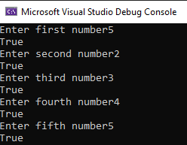

1. Write a program that reads five numbers from the console and prints the **greatest** of them.

using System;

using System.Collections.Generic;

using System.Linq;

using System.Text;

using System.Threading.Tasks;

namespace Chapter_4_Solution_8

{

class Program

{

static void Main(string[] args)

{

Console.Write("Enter first number");

int a = Int32.Parse(Console.ReadLine());

Console.Write("Enter second number");

int b = Int32.Parse(Console.ReadLine());

Console.Write("Enter third number");

int c = Int32.Parse(Console.ReadLine());

Console.Write("Enter fourth number");

int d = Int32.Parse(Console.ReadLine());

Console.Write("Enter fifth number"); int e= Int32 .Parse ( ConsoleReadLine());

if (a > b && a > c && a > d && a > e) Console.WriteLine("{0} is the biggest.", a);

else if (b > a && b > c && b > d && b > e) Console.WriteLine("{0} is the biggest.", b);

else if (c > a && c > b && c > d && c > e) Console.WriteLine("{0} is the biggest.", c);

else if (d > a && d > b && d > c && d > e) Console.WriteLine("{0} is the biggest.", d);

else if (e > a && e > b && e > c && e > d) Console.WriteLine("{0} is the biggest.", e);

else Console.WriteLine("There isn't a biggest number.");

}

}

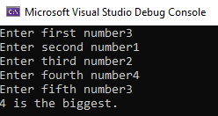}

1. Write a program that reads an integer number **n** from the console. After that reads **n** numbers from the console and prints their **sum**.

using System;

using System.Collections.Generic;

using System.Linq;

using System.Text;

using System.Threading.Tasks;

namespace Chapter_4_Solution_9

{

class Program

{

static void Main(string[] args)

{

double d, x1, x2;

Console.Write("Enter A (A != 0): ");

double a = Int32.Parse(Console.ReadLine());

Console.Write("Enter B: ");

double b = Int32.Parse(Console.ReadLine());

Console.Write("Enter C: ");

double c = Int32.Parse(Console.ReadLine());

d = b * b - 4 * a * c;

if (d < 0) Console.WriteLine("D={0}, There are no real roots.", d);

else if (d == 0)

{

x1 = (-b / (2 * a));

Console.WriteLine("X={0}", x1);

}

else

{

x1 = (-b + Math.Sqrt(d)) / (2 * a);

x2 = (-b - Math.Sqrt(d)) / (2 * a);

Console.WriteLine("X1={0}, X2={1}", x1, x2);

}

}

}

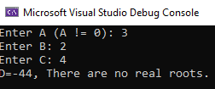}

1. Write a program that reads an integer number **n** from the console and **prints** **all numbers in the range** **[1…n]**, each on a separate line.

using System;

namespace ConsoleApp18

{

class Program {

static void Main(string[] args)

{

static void Main(string[] args)

{

int sum = 0;

Console.Write("Enter numbers count: ");

int length = Int32.Parse(Console.ReadLine());

for (int i = 0; i < length; i++)

{

Console.Write("Enter {0} number: ", i + 1);

sum += Int32.Parse(Console.ReadLine());

}

Console.WriteLine("Sum of all numbers is {0}.", sum);

}

}

}

}

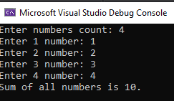

1. Write a program that prints on the console the first 100 numbers in the **Fibonacci sequence**: 0, 1, 1, 2, 3, 5, 8, 13, 21, 34, 55, 89, 144, 233, …

using System;

namespace ConsoleApp19

{

class Program

{

static void Main(string[] args) {

static void Main(string[] args)

{

int sum = 0;

Console.Write("Enter number: ");

int length = Int32.Parse(Console.ReadLine());

for (int i = 1; i <= length; i++)

{

Console.WriteLine(i);

}

}

}

}

}

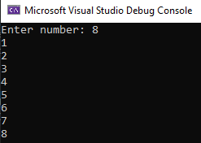

12.   Write a program that calculates the **sum** (with **precision of 0.001**) of the following sequence: 1 + 1/2 - 1/3 + 1/4 - 1/5 + …

using System;

namespace ConsoleApp19

{

class Program

{

static void Main(string[] args)

{

static void Main(string[] args)

{

int num1 = 0;

int num2 = 1;

int sum = 1;

int count = 0;

Console.WriteLine(num1);

while (count < 100)

{

sum = num1 + num2;

num1 = num2;

num2 = sum;

Console.WriteLine(num2);

count++;

}

}

}

}

}

